**Total Summaries:**

* **Lane Miles Summary**

|  |  |  |  |
| --- | --- | --- | --- |
| IFC | Functional_Class | Lane_Miles | Percent |
| 1 | Freeway | 93,963,411 | 11.37 |
| 2 | Prime arterial | 25,176,344 | 3.05 |
| 3 | Major arterial | 100,174,848 | 12.12 |
| 4 | Collector | 75,594,442 | 9.15 |
| 5 | Local collector | 111,841,779 | 13.53 |
| 6 | Rural collector | 30,528,604 | 3.69 |
| 7 | Local Road | 105,812,322 | 12.8 |
| 8 | Freeway ramps | 9,503,071 | 1.15 |
| 9 | Local ramps | 34,932,530 | 4.23 |
| 10 | Zone connectors | 238,931,691 | 28.91 |
|  | TOTAL | 826,459,042 | 100 |

* **Speed Summaries**

|  |  |  |  |  |
| --- | --- | --- | --- | --- |
| IFC | Functional_Class | Min_Speed | Max_Speed | Flag |
| 1 | Freeway | 45 | 70 | 1 |
| 2 | Prime arterial | 30 | 65 | 1 |
| 3 | Major arterial | 25 | 65 | 1 |
| 4 | Collector | 15 | 55 | 0 |
| 5 | Local collector | 15 | 65 | 1 |
| 6 | Rural collector | 20 | 55 | 0 |
| 7 | Local Road | 15 | 50 | 0 |
| 8 | Freeway ramps | 30 | 70 | 0 |
| 9 | Local ramps | 20 | 65 | 0 |
| 10 | Zone connectors | 20 | 45 | 0 |

* **Number of Lanes**

|  |  |  |  |  |  |  |  |  |
| --- | --- | --- | --- | --- | --- | --- | --- | --- |
| IFC | Functional_Class | Max AB Lanes (AM) | Max AB Lanes (OP) | Max AB Lanes (PM) | Max BA Lanes (AM) | Max BA Lanes (OP) | Max BA Lanes (PM) | Flag |
| 1 | Freeway | 7 | 7 | 7 | 0 | 0 | 0 | 0 |
| 2 | Prime arterial | 5 | 5 | 5 | 5 | 5 | 5 | 0 |
| 3 | Major arterial | 9 | 9 | 5 | 5 | 5 | 5 | 1 |
| 4 | Collector | 4 | 4 | 4 | 4 | 4 | 4 | 0 |
| 5 | Local collector | 4 | 4 | 4 | 4 | 4 | 4 | 0 |
| 6 | Rural collector | 2 | 2 | 2 | 2 | 2 | 2 | 0 |
| 7 | Local Road | 4 | 4 | 4 | 4 | 4 | 4 | 0 |
| 8 | Freeway ramps | 3 | 3 | 3 | 1 | 1 | 1 | 0 |
| 9 | Local ramps | 4 | 4 | 4 | 3 | 3 | 3 | 0 |
| 10 | Zone connectors | 1 | 1 | 1 | 1 | 1 | 1 | 0 |

* **Toll Summary(IFC)**

|  |  |  |  |  |  |  |  |
| --- | --- | --- | --- | --- | --- | --- | --- |
| IFC | Min Toll (OP) | Max Toll (OP) | Min Toll (AM) | Max Toll (AM) | Min Toll (PM) | Max Toll (PM) | Flag |
| 1 | **0** | **142** | **0** | **145** | **0** | **145** | **0** |
| 2 | **0** | **0** | **0** | **0** | **0** | **0** | **0** |
| 3 | **0** | **0** | **0** | **0** | **0** | **0** | **0** |
| 4 | **0** | **0** | **0** | **0** | **0** | **0** | **0** |
| 5 | **0** | **0** | **0** | **0** | **0** | **0** | **0** |
| 6 | **0** | **0** | **0** | **0** | **0** | **0** | **0** |
| 7 | **0** | **0** | **0** | **0** | **0** | **0** | **0** |
| 8 | **0** | **1** | **0** | **1** | **0** | **1** | **0** |
| 9 | **0** | **67** | **0** | **67** | **0** | **67** | **0** |
| 10 | **0** | **0** | **0** | **0** | **0** | **0** | **0** |

* **Toll Summary(IHOV)**

|  |  |  |  |  |  |  |  |
| --- | --- | --- | --- | --- | --- | --- | --- |
| IHOV | Min Toll (OP) | Max Toll (OP) | Min Toll (AM) | Max Toll (AM) | Min Toll (PM) | Max Toll (PM) | Flag |
| 1 | **0** | **0** | **0** | **0** | **0** | **0** | **0** |
| 2 | **0** | **35** | **0** | **92** | **0** | **92** | **0** |
| 4 | **0** | **142** | **0** | **145** | **0** | **145** | **0** |

1. **Freeways**

Checks for three scenarios. Freeways in A, B and C networks have some differences due to different projects but all of them are consistent with projects definition

* **Network Consistency for Toll lanes**

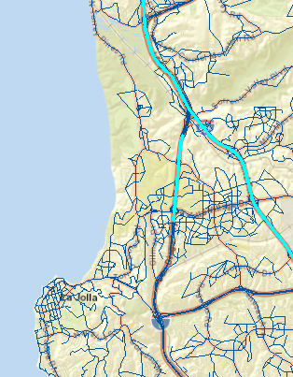

The ramp for connecting HOV lane has toll=0 whereas the upstream and downstream links have tolls

* **Check for managed lanes**: Arterial and centroid connectors are not coded as managed lanes.
* **Manage Lanes with Toll=0:** There are 316 links (Freeways and ramps) coded as managed lanes with toll=0. It might be because of the tolling has been implanted on network. Links have been documenter and might be considered for further checks
* **Link Speeds:**

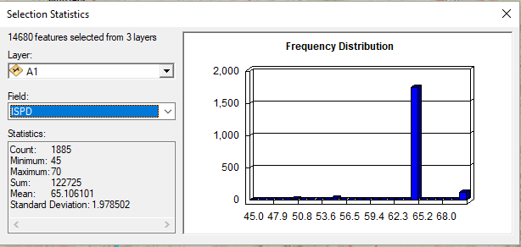

Detect Freeways < 55mph posted speed: 12 links were found and saved. They are in two locations:

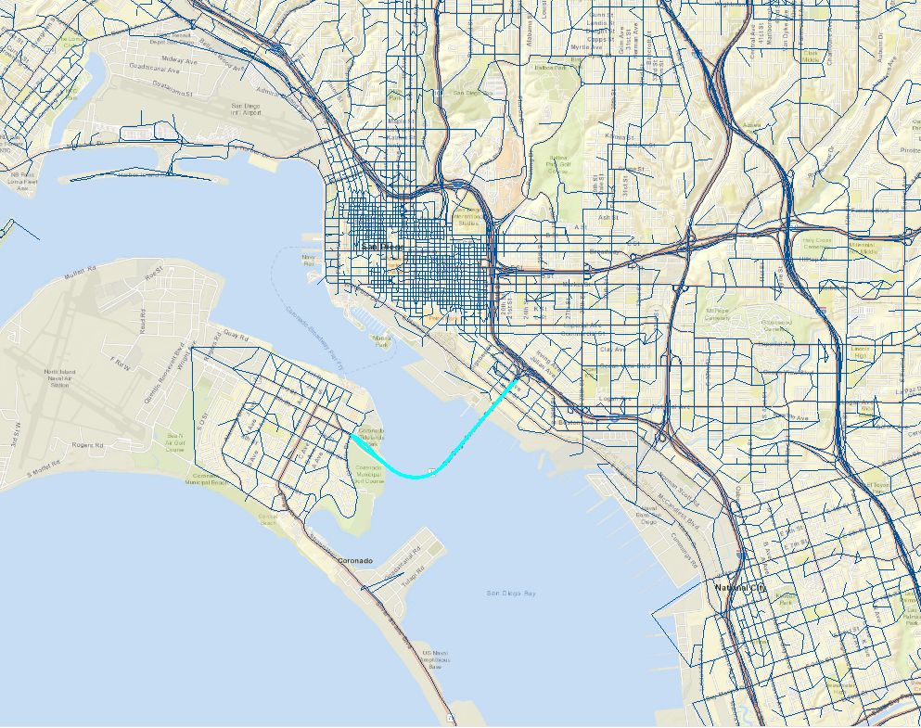

SR75 between I5 and Glorietta. The posted speed based on google map is 55mph

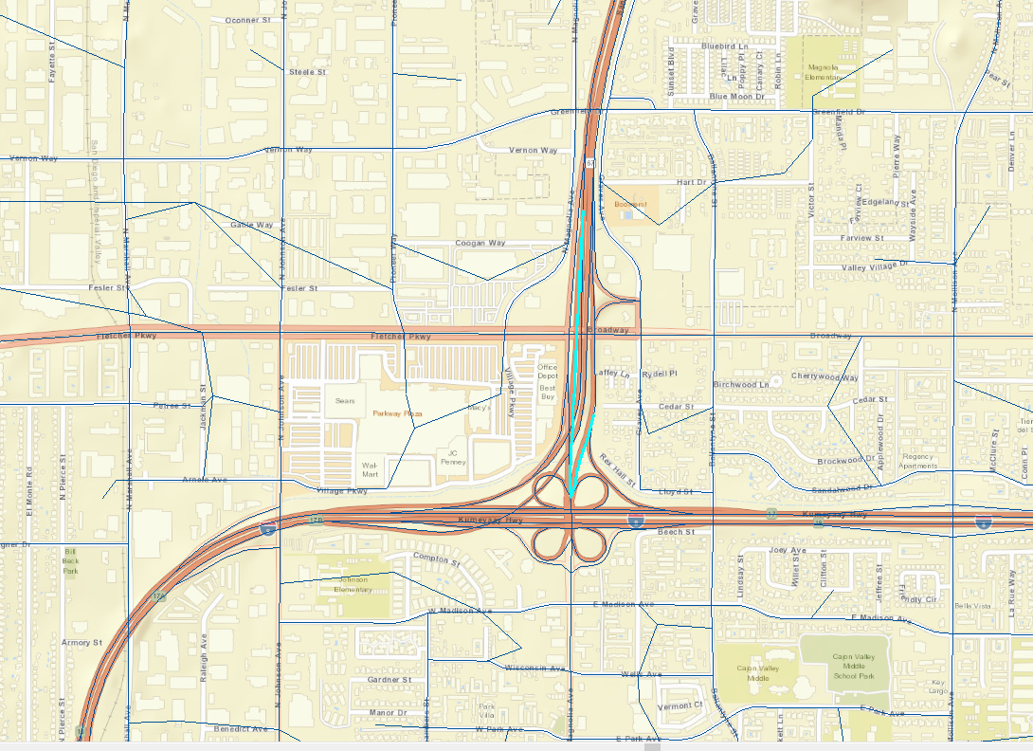

SR67 from Fletcher Pkwy to I8: Checked with google map and the posted speed is 45 and 50 mph

* **Number of lanes**: Checked some links with Google map and they are coded correctly

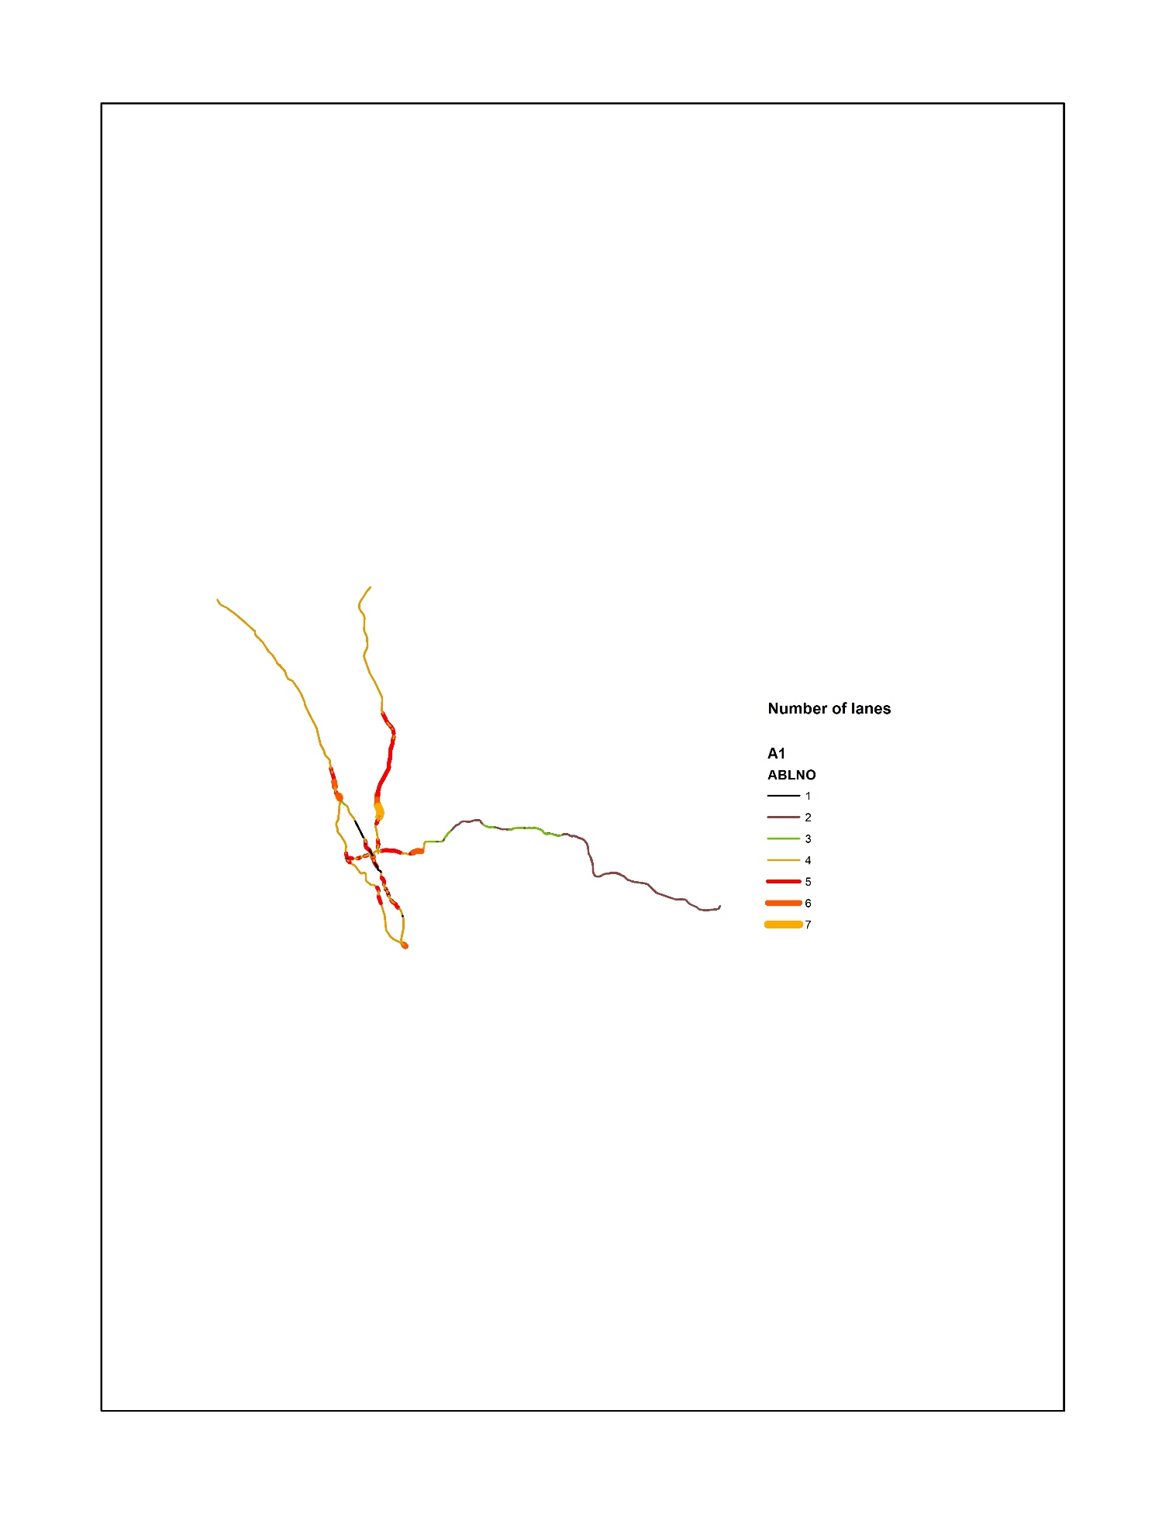

* **Capacity Check:**

**All Freeway lanes have 1900 and 2100 veh/hour capacity**

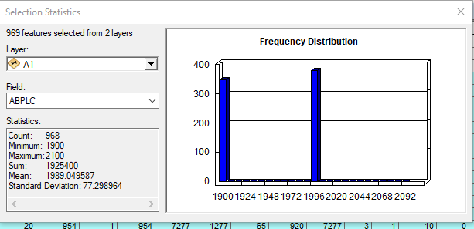

1. **Arterials:**

Networks A, B and C are same for IFC=2 (no project in arterial level)

* **Link Speeds:**

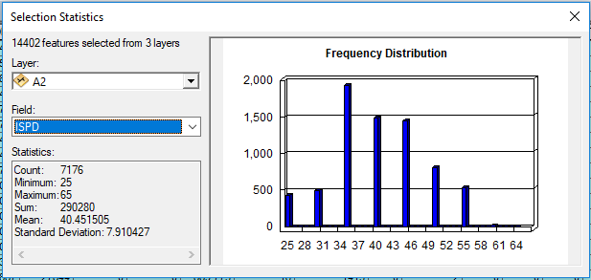

Distributions looks correct. Checked some links by Google Map and the speeds were coded correctly.

**Arterials > 60mph posted speed** there are 23 arterial links with posted speed>60 in two roads:

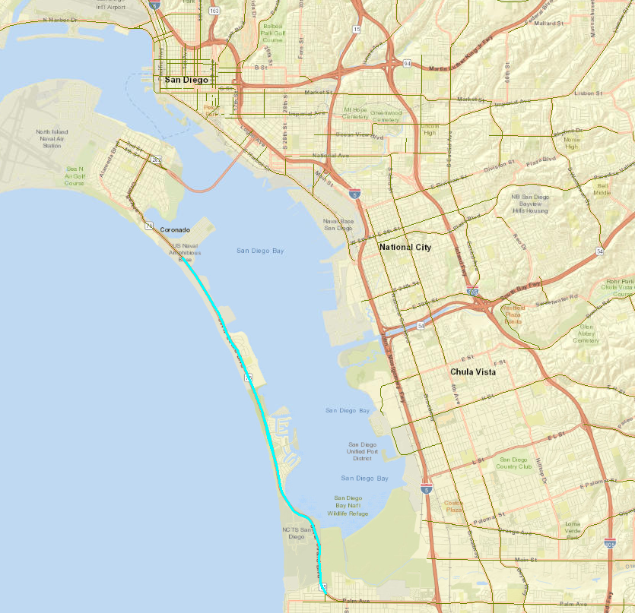

Silver Strand Blvd. Checked with google map and it has 65 speed limit.

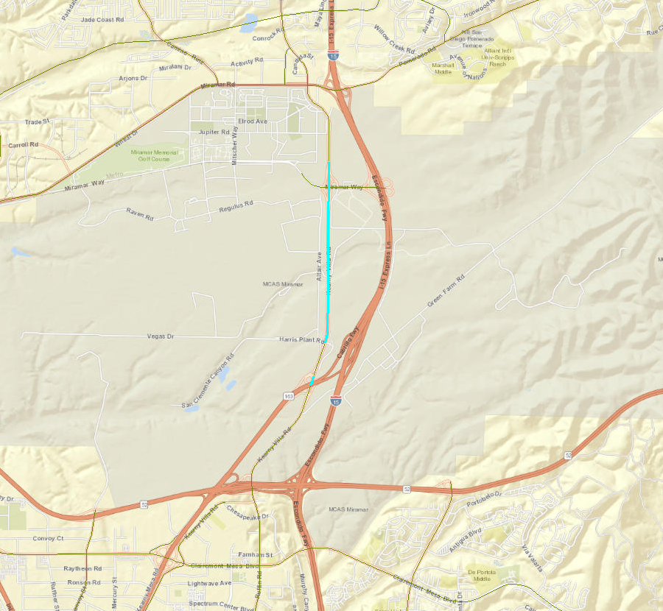

Kearny Villa Road: Checked with google maps. Posted speed is 65 mph

**Number of lanes:**

**Two arterial links with 9 lanes**: links located in 5th street to I-5.

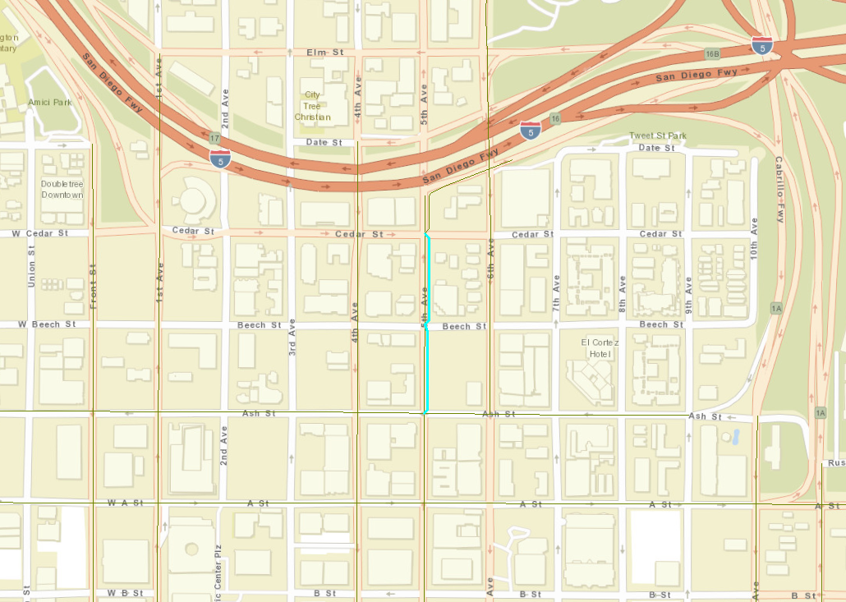

Checked the lanes on other links: Found 3 links with 5 lanes; checked them with google map and they are coded correctly

**Right and Left turn lanes:**

Two potential issues were found:

There are links with 7,8,9 number of right or left turn lanes.

Checked some of the links with google map and they are not completely consistent. For example, the lane has two left lanes but it is coded as 1)

**Capacity check:**

Too many links with zero capacities: Only 70 out of 1318 links have non-zero capacities. (all 70 have 950 veh/hr).

IWAY, IHOV and TOLL also checked and all are correct.

1. **Collectors:**

* **Link Speed:**

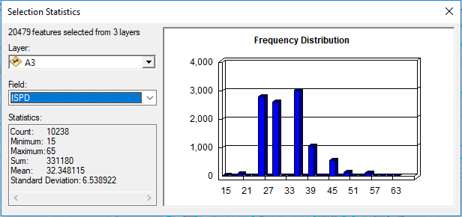

There is a link with 65 mph posted speed.

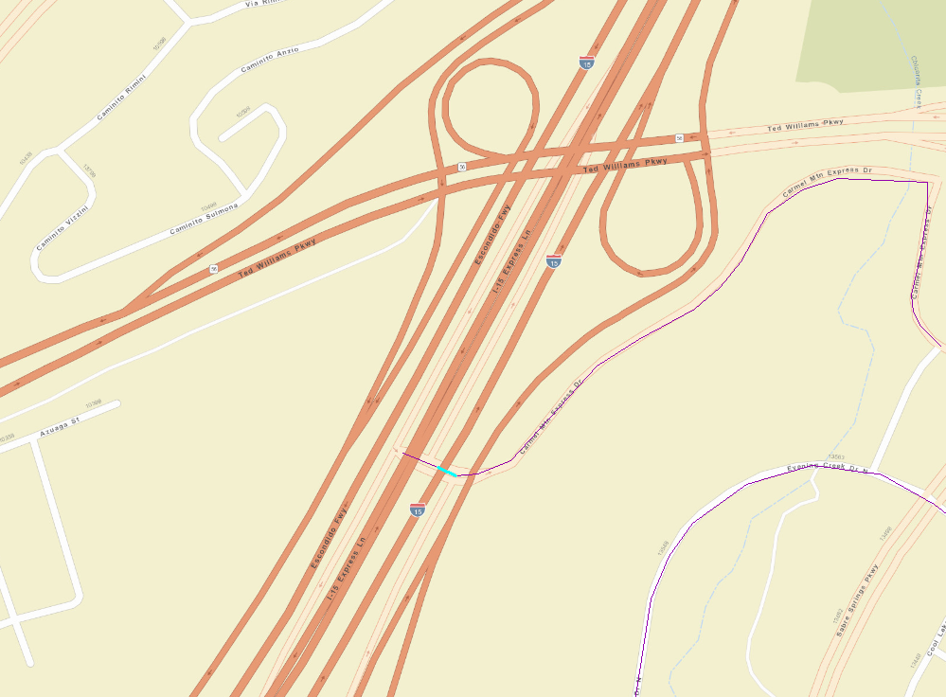

Ted Williams DAR: 65 mph is not consistent with google map (posted speed is 30mph)

* **Number of lanes:**

Checked the 4 lanes link with google map and they are consistent.

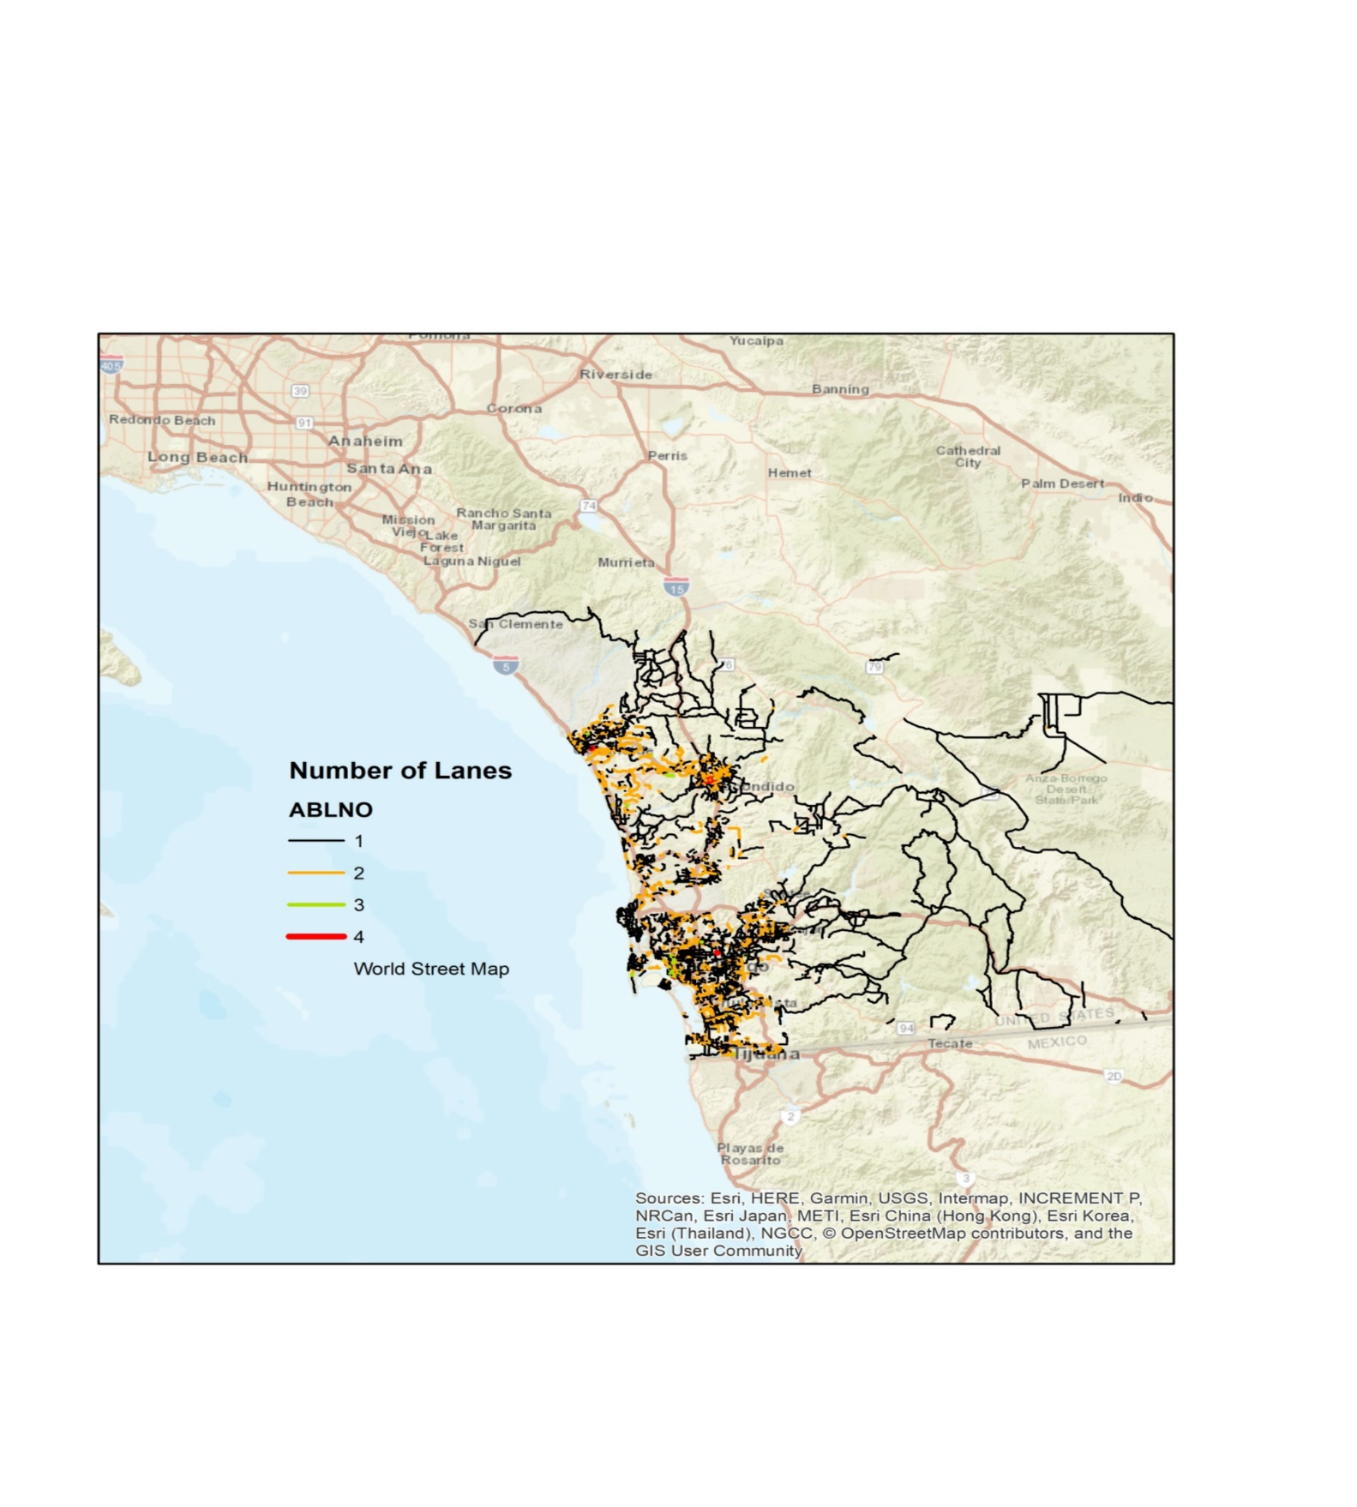

**Right and Left turn lanes:**

Two issues:

There are links with 7,8,9 number of right or left turn lanes.

Checked some of the links with google map and they are not completely consistent. ( For example, the lane has two left lanes but it is coded as 1)

**Capacity check:**

Too many links with zero capacities

1. Local Roads:

* **Link Speed**

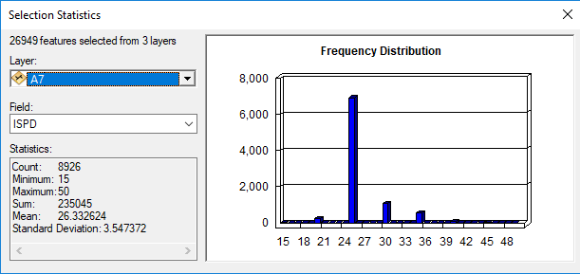

* **Number of lanes**

Checked the 4 lanes link with google map and they are consistent.

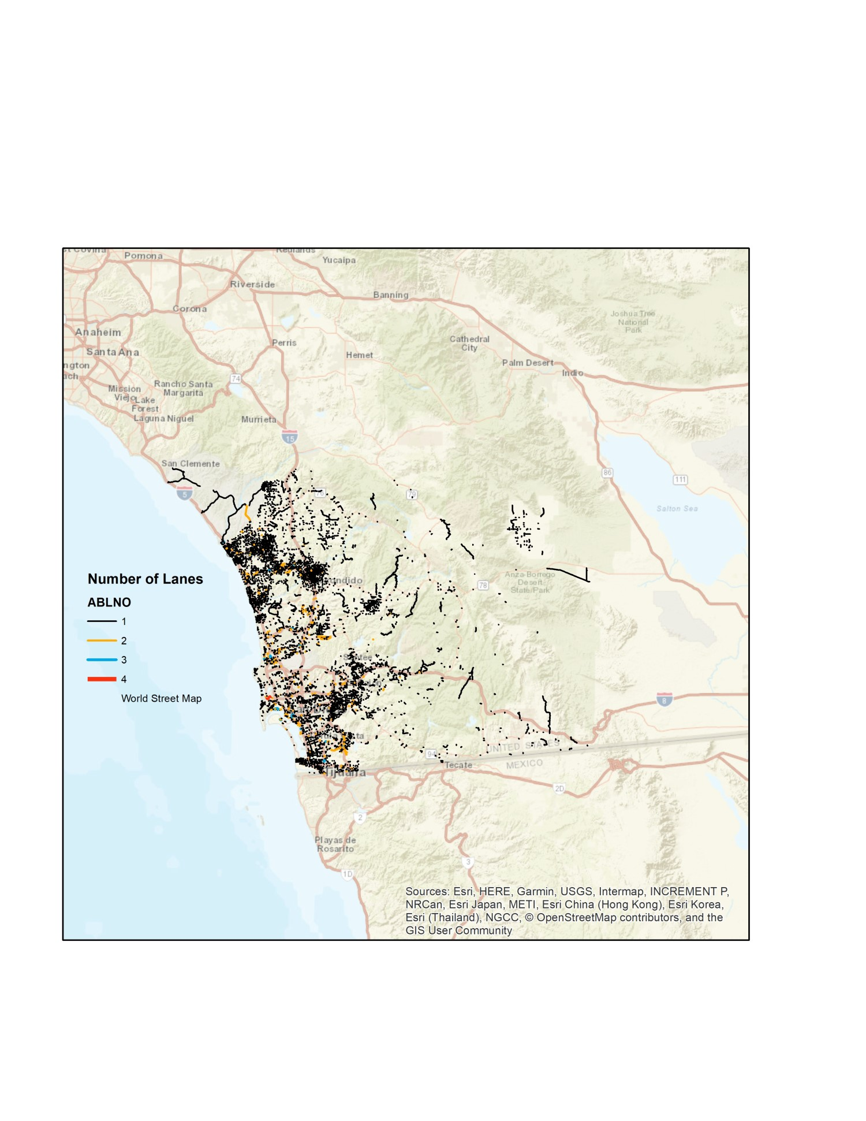

**Right and Left turn lanes:**

Two issues:

There are links with 7,8,9 number of right or left turn lanes.

Checked some of the links with google map and they are not completely consistent. For example, the lane has two left lanes but it is coded as 1)

**Capacity check:**

Too many links with zero capacities

1. **Ramps**

* **Link Speed**

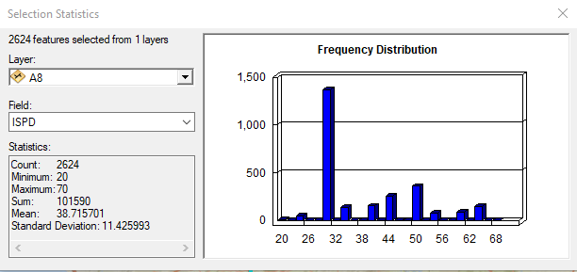

* **Number of lanes**

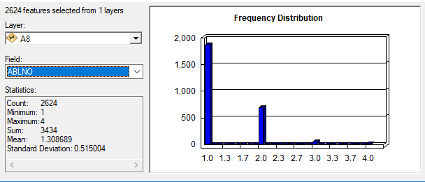

**Right and Left turn lanes:**

Two issues:

There are links with 7,8,9 number of right or left turn lanes.

Checked some of the links with google map and they are not completely consistent. (For example, the lane has two left lanes but it is coded as 1)

**Capacity check:**

Too many links with zero capacities

1. **Zone Connectors:**

* **Speed:**

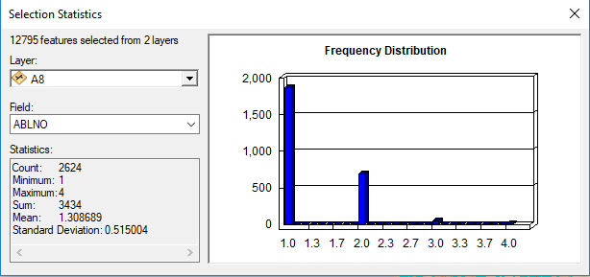

* **no Centroids with toll value**
* **number of lanes: all 1**